ĐỀ THI TIẾNG ANH Mã đề: 09
Trình độ A2
Họ và tên thí sinh: ……………..……………………………………………………….…………………………………………………………
Số báo danh: ……………..…………………………………………...……. Phòng thi số: …………………………….……………

PAPER TWO LISTENING (Approximately 15 minutes)
PART 1: Questions 1 – 5
There are five questions in this part. For each question there are three answer choices and a short recording. Tick (√) the correct answer. You will hear the piece twice.
Example: How many people were at the meeting?
A. 3 B. 13 √ C. 30
1. What time will the the taxi arrive at the woman’s house?
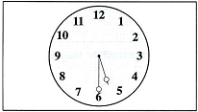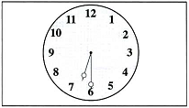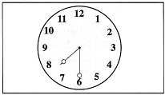
A □ 5h30 -6h30-7h30 B □ C □
2. What will they give George?
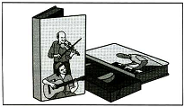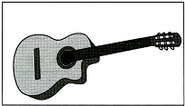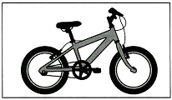
A □ B □ C □
3. Where will they sit?
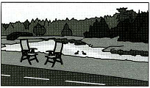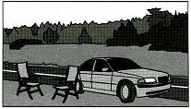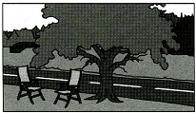
A □ B □ C □
4. What size does the woman buy?
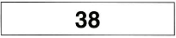
A □ thiry-eight/fourty/fourty-two B □ C □
5. Which ice cream will they have?
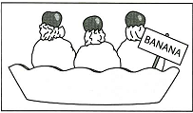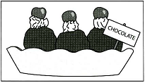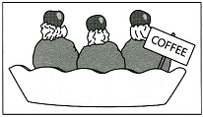
A □ B □ C □

PART 2: Questions 6-10
Listen to Jim and Julie talking about a party. What do the guests want to eat or drink?
For questions 6-10, write a letter A-H next to each person. You will hear the conversation twice.

EXAMPLE | ANSWER
0 Kevin | E
PEOPLE |  | FOOD AND DRINK
6 Barbara F  7 PaulC  8 DianaD  9 JimB  10 JulieG |  | A coffee  B coke  C ice-cream  D milk  E orange juice  F sandwich  G tea  H water

PART 3: Questions 11-15
Listen to Anne asking her friend about going to a shopping centre.
For questions 11-15, tick (√) A, B, or C. You will hear the conversation twice.
Example: 0. The name of the new shopping centre is
A. The Rivers
B. The Forest Centre
C. Queen’s
11. At the moment, the shopping centre sells
A. clothes
B. books
C. food
12. You can take coach to the shopping centre on
A. Mondays
B. Tuesdays
C. Saturdays
13. Anne’s coach ticket will cost
A. £2.50 two pound fifty
B. £5.60 five pound sixty
C. £10.80 ten pound eighty
14. The nearest coach stop to Anne’s house is
A. in the bus station
B. in the market square
C. outside the museum
15. The coach journey takes
A. 10 minutes
B. 20 minutes
C. 40 minutes

